#### Memo Apps



UNDERGRADUATE PROJECT

Submitted in partial fulfillment of the requirements of

software development project 2 for the degree of

B.Sc Engg. in CSE

#### By

*GROUP: Team Sparta*

#### UNDER SUPERVISION OF:

Dipu Akter Shila

Teaching Assistant

Dept. of CSE

Bangladesh University of Business and Technology.

BANGLADESH UNIVERSITY OF BUSINESS

& TECHNOLOGY(BUBT)

##### Dhaka - 1216

##### March - 2021

#### Memo Apps

Group Members

Name ID

Md. Tanvir Rahman 18192103248

Zannatun Nayem Smriti 18192103120

Md. Mostafizur Rahman 18192103254

**Team Sparta**



BANGLADESH UNIVERSITY OF BUSINESS

&

TECHNOLOGY

(BUBT)

DEPARTMENT OF COMPUTER SCIENCE &ENGINEERING

Declaration of Authorship

We, Md. Tanvir Rahman, Zannatun Nayem Smriti, Md. Mostafizur Rahman declare that this project titled,” Memo Apps” and the work presented in it are our own. We confirm that:

* This work was done wholly or mainly while in candidature for a B.Sc Engineering in CSE degree at this University.
* Where any part of this software development project has previously been submitted for a degree or any other qualification at this University or any other institution, this has been clearly stated.
* Where we have consulted the published work of others, this is always clearly attributed.
* Where we have quoted from the work of others, the source is always given. With the exception of such quotations, this thesis is entirely our own work.
* We have acknowledged all main sources of help.
* Where the thesis is based on work done by ourself jointly with others, we have made clear exactly what was done by others and what we have contributed myself.

***Md. Tanvir Rahman***

ID:18192103248

Date:

***Zannatun Nayem Smriti***

ID:18192103120

Date:

***Md. Mostafizur Rahman***

ID: 18192103254

Date:

Certificate

This is to certify that the project entitled, “**Memo Apps**” and submitted by **Md. Tanvir Rahman (19102103248), Zannatun Nayem Smriti(19102103120), Md. Mostafizur Rahman(19102103254)** in partial fulfillment of the requirements of embodies the work done by them under my supervision.

***Dipu Akter shila***

Teaching Assistant, Department of CSE Bangladesh University of Business and Technology

Date:

*Dedication*

*Dedicated to our parents and Dipu Akter Shila for all their*

*love and inspiration.*

Abstract

The Memo Apps deals with automatic food order system, it sent chosen food list and price as a mail to kitchen. It also has a payment system and verification system. Memo Apps saved data from user and show graph chart for owner monthly profit or loss. And it also has a developer mood for calculate all of data for owner of a restaurant.

Acknowledgement

First of all, we are thankful and expressing our gratefulness to Almighty Allah who offers us His divine blessing, patient, mental and physical strength to complete this project work.

We are deeply indebted to our project supervisor Dipu Akter shila, Lecturer, Department of Computer Science and Engineering (CSE), Bangladesh University of Business and Technology (BUBT). His scholarly guidance, important suggestions, work for going through our drafts and correcting them, and generating courage from the beginning to the end of the research work has made the completion of this thesis possible.

A very special gratitude goes out to all our friends for their support and help to implement our works. The discussions with them on various topics of our works have been very helpful for us to enrich our knowledge and conception regarding the work.

Last but not the least; we are highly grateful to our parents and family members for supporting us spiritually throughout writing this thesis and our life in general.

Approval

This project “Memo Apps” Submitted by Md.Tanvir Rahman, Zannatun Nayem Smriti, Md.

Mostafizur Rahman ID : 18192103248, 18192103120 and 18192103254 Department of computer

science and engineering (cse), Bangladesh university of business and technology (BUBT) under

the supervision of Dipu Akhter Shila, Teaching assistant , Department of computer science and

engineering has been accepted as satisfactory for the partial fulfilment of the requirement for the

degree of bachelor science (B.Sc engg.) in computer science and engineering and approved as to

it’s style and contents

***Supervisor:***

***Dipu Akter Shila***

*Teaching Assistant*

Department Of CSE

*Bangladesh University of Business and Technology (BUBT)*

**Chairman:**

***Dr.Muhammad Firoz Mridha***

Associate Professor And chairman

Department Of CSE

*Bangladesh University of Business and Technology (BUBT)*

All the introductions and application part are the above of the Report.

|  |
| --- |
| * Chapter - 1: Introduction……………………………………............1 - 4 * Chapter - 2: Technologies…………………...……………......5 - 7 * Chapter – 3: System Analysis and Architectural Design……8 - 11 * Chapter - 4: Access System…………...….….………….…12 - 18 * Chapter - 5: Perfection………...……………………...……19 - 22 * Resources ……………….….…………...……….…………….23 |

**Chapter 1**

**Introduction**

##### 

**1.1 Introduction**

The memo apps are really useful for every big or small restaurant. We make it for

reduce restaurant waiter and it costs. Also digitalized restaurants waiter, customer

system and payment system. It’s also is essential for aristocracy, because a customer

come to restaurant then he orders food by this apps automatically, customers able to

message waiter for any reason by this apps. If he needed something then he able

to send message. Here a customer able to payment online he doesn’t need to pay

money(cash) by traditional way. Customersjust opens his Bkash or Nogad apps and

then scan to payment by online system.We also make many helpful systems for owner.

This software has a money verification system and it has digital and useful database

system that give exactly useful calculation for restaurant-owner. It also has some

security system for the owner. In this app the waiter and customers can’t able to delete

anything. The system data page has a security system that only one person able to access

it so no one can’t able to remove data from system table. It also has a chart for showing

owner to restaurants profit or loss. There also has a restaurant system calculator for

calculate restaurant profit or loss and many simple calculations. It so very necessary and

useful for todays every restaurant.

**Project Review**

**Project Database**

In this project database create some useful system for this apps because In this software database table calculate every thing for the owner. It make useful chart that show the owner his resutrants everydays profit and loss. This way no one can not cheating with the owner because everything can’t able to be deleted and its protected by security issue. For this only the owner can access this part so no one cant deleted this data. Its so many useful.

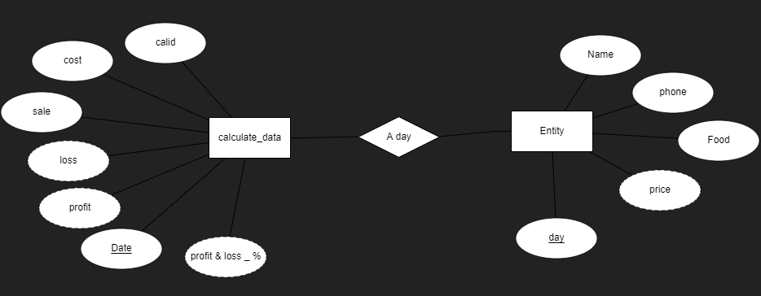

Figure 2.1: ER Diagram

**Database Management System**

We see that everything is be software based in this world but restaurant system is same before like 300 year ago. So, I think that I can able to be change this system. I want to make a fully software-based system by simple knowledge. I’m sure that it is so useful for every restaurant. It reduces waiter every restraint. This software vanishes counter man because it has online payment system. And it also has developer’s mood to calculate every single of money this why the owner of the restaurant is always able to be satisfied for calculate everything and reduce restaurants loses. I think this system of software reduce owner loss and create useful and increase aristocracy for every restaurant.

##### 

**Memo Apps & Database Management**

In this project database create some useful system for this apps because In this software database table calculate every thing for the owner. It make useful chart that show the owner his resutrants everydays profit and loss. This way no one can not cheating with the owner because everything can’t able to be deleted and its protected by security issue. For this only the owner can access this part so no one cant deleted this data. Its so many useful. A DBMS is a complex set of software programs that controls the organization, storage, management, and retrieval of data in a databaseWhen a DBMS is used, information systems can be changed much more easily as the organization’s information requirements change. New categories of data can be added to the database without disruption to the existing system. Organizations may use one kind of DBMS for daily transaction processing and then move the detail onto another computer that uses another DBMS better suited for random inquiries and analysis.

**Advantages of DBMS**

* + - Improved strategic use of corporate data
    - Reduced complexity of the organization’s information systems environment
    - Reduced data redundancy and inconsistency
    - Enhanced data integrity
    - Application-data independence
    - Improved security
    - Reduced application development and maintenance costs
    - Improved flexibility of information system
    - Increased access and availability of data and information
    - Logical Physical data independence
    - Concurrent access anomalies.
    - Facilitate atomized problem.
    - Provides central control on the system through DBA.

##### 

**2.2 Client Records / Data Table**

In There we save all of customers data in a database table for verification and fulfil restaurants owner’s calculation.

* + - It saves data on table for verification;
    - Owner can search here by customer’s number;
    - This software show date and exact time to owner.
    - It providing support to the owner for his every day exactly calculation.

In this system we can’t save any personal message to our table we just saved price, food list, phone number and the customer’s name for verification. In the calculation system we do sum of ever days data and find profits and loss and its percentage by it.

3

**Resources**

##### 

**3.1 System Development life Cycle**

The system development life cycle is a project management model that defines the stages involved in bringing a project from inception to completion. Software development teams, for example, deploy a variety of systems development life cycle models that include waterfall, spiral and agile processes.

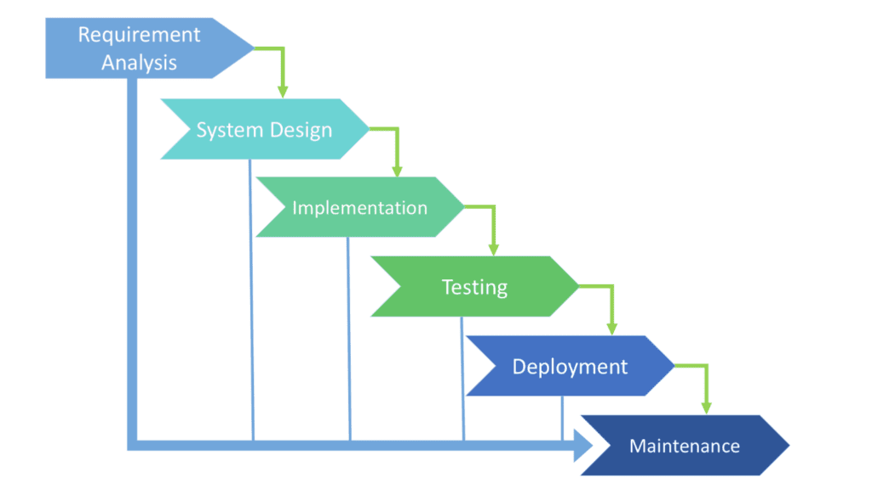

Figure 3.1: SDLC Phases

There are six phases in this model and the first phase is the Requirement Analysis. The Requirement Analysis stage determines the objectives of the project and whether the project should be given the green light to proceed and also startup thing for planning project.

The System Design part is always help to how to we fulfil this project it’s the second stage for complete a project. In this stage the user requirements in mind, the flow of the system is planned and the user interface is designed to suit their easy navigation needs. In addition, the number of tables, attributes, primary and unique keys of the database is listed.

After completing the design, actual coding begins. Database is created and codes are written. Some of the codes required amendments and improvement to it so these are being developed at this fourth stage of the waterfall model. With the development completed, testing will begin.

The codes and database are tested to ensure the results obtained are as intended. More time is spent on both development and testing stages because it is inevitable to have errors and issues and buffer time is allocated for troubleshooting.

In this Deployment process we able to recover all of our mistakes after testing. In there always call debugging part for a project. In there we should debug our project.

The Maintenance stage we always arranged our code and algorithm for update this project and We also arranged there our design and fulfill all requirement for this project.,

4

**Chapter 2**

**Technologies**

##### 

* 1. **Software**
     1. **Visual Studio**

For making this software we can use visual studio community. Visual Studio is a great IDE for. Net based applications and has lots of features. It is used to develop web applications, windows applications, web services, windows services and mobile applications.



Figure 4.1: **Visual Studio**

We use localhost database for this software database system so we

install XAMPP connector. XAMPP is an abbreviation for cross-platform, Apache, MySQL, PHP and Perl, and it allows you to build WordPress site offline, on a local web server on your computer. This simple and lightweight solution works on Windows, Linux, and Mac – hence the “cross-platform” part.



Figure 4.1.1: **XAMPP**

5

##### 

* 1. **Programming Language**

**4.2.1 C# language**

C# is a high-level language so it is closer to other popular programming languages like C, C++, and Java and thus becomes easy to learn for anyone. Widely used for developing Desktop and Web Application: C# is widely used for developing web applications and Desktop applications. It is one of the most popular languages that is used in professional desktop. If anyone wants to create Microsoft apps, C# is their first choice. Community The larger the community the better it is as new tools and software will be developing to make it better. C# has a large community so the developments are done to make it exist in the system and not become extinct. Game Development: C# is widely used in game development and will continue to dominate. C# integrates with Microsoft and thus has a large target audience. The C# features such as Automatic Garbage Collection, interfaces, object-oriented, etc. make C# a popular game developing language.



Figure 4.2: C# Language

MySQL is a relational database management system based on SQL – Structured Query Language. The application is used for a wide range of purposes, including data warehousing, e-commerce, and logging applications. The most common use for MySQL however, is for the purpose of a web database.



Figure 4.2.1: MySQL Query .

**Chapter 3**

**System Analysis & Architectural Design**

**5.1 System User Analysis**

The **Memo Apps** has three types of user and they can access the system.

**USER:**

* + - Owner.
    - Customers.
    - Chef.

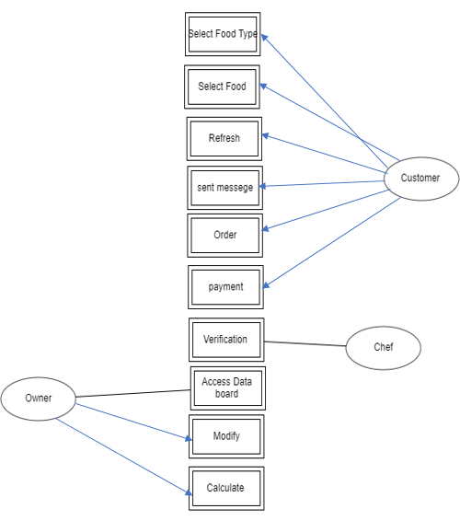

Figure 5.1: **User** **Analysis**

8

* + 1. **Owner:**

In our software system just owner able access most secret side. There an owner can access system data board, He able to modify data, and he able to calculate data. In this part has some security system it only able to use a owner who know this security code so no one cant able to go to this part.

**5.1.2 Customers:**

In software system a customer’s able to select food item, refresh it and he also able to send message to restaurants waiter and kitchen, and he also able to pay money by this apps.

**5.1.2 Chef:**

This is the main part, because all of the software system work done in this stage. After a customer’s sent money, he sends his phone number and sit number by this software for verification. Then the chef checks that the number that give money and message number then the chef make food for this order and tell waiter to seat number for serve food there.

* 1. **Architectural design**

The memo apps have a clean UI for user. In this project we think that our users are not developer so it’s able to be the user-friendly software. So, this why we make a clean UI and mostly user-friendly software. Its working well and it’s using system are so easy. We showed this design below.

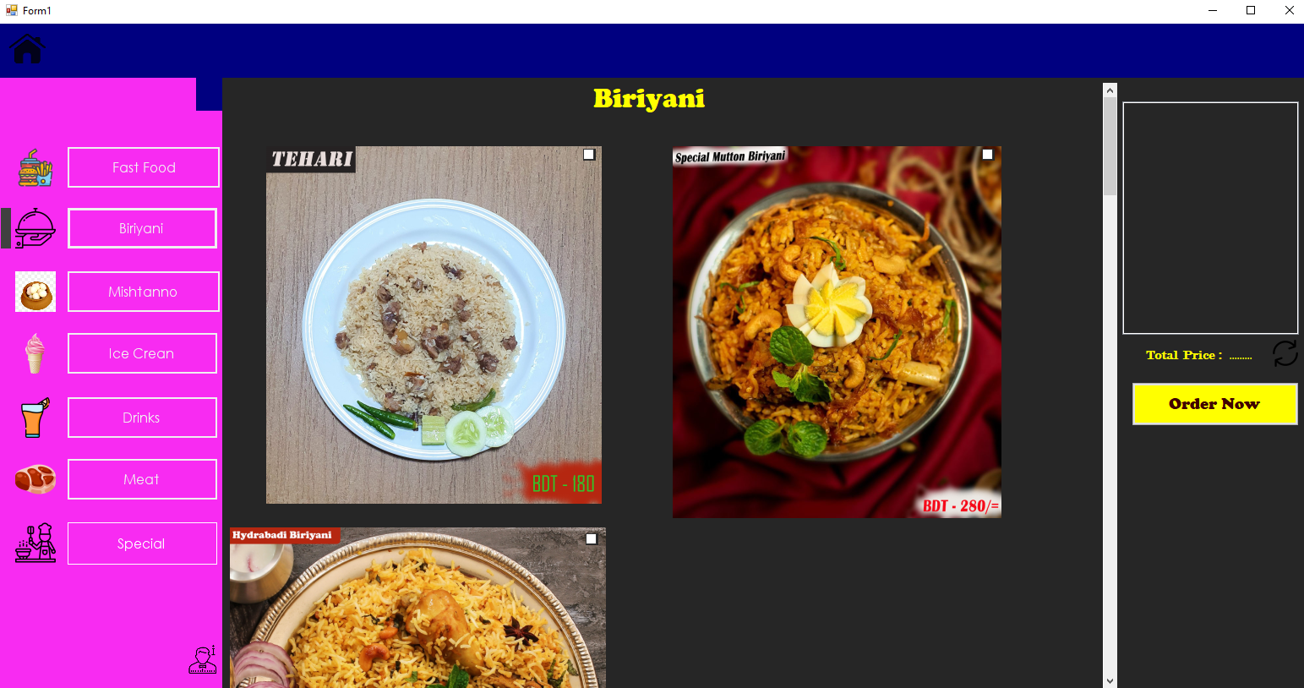

Figure 5.2.1: **Design - Home**

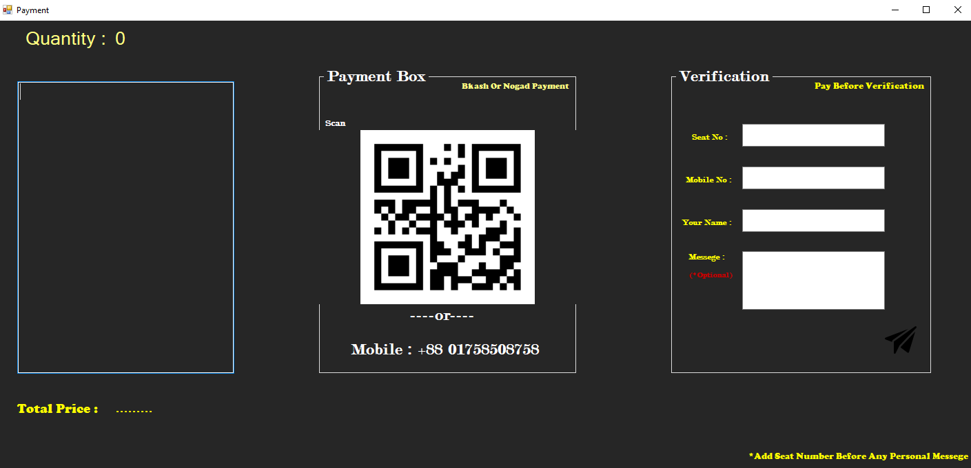

Figure 5.2.2: **Design - Payment and order Pag**e

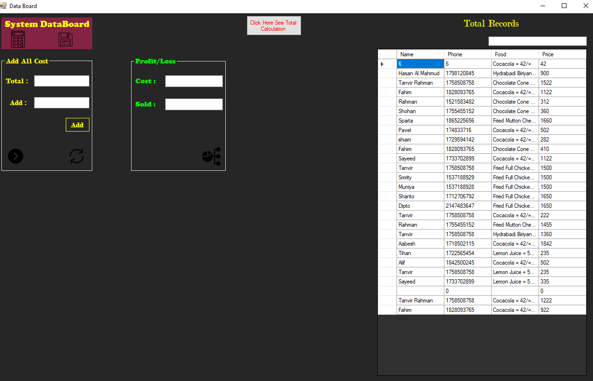

Design 5.2.3: **Design - system Data board**



Design 5.2.4: **Design - About us.**

**Chapter 4**

**Access System**

##### 

**6.1 Description**

By reading this chapter user can know about every options of this system as like, how to use and owner operate this Software.

##### 

**6.1 Manual**

1. After run this software. This is the view of home page.



Figure 6.1: **Design of Home page**

12

1. It’s the select item process. You just click the checkbox on given food then it automatically happens.

If you need to select same food 2 time just double click on the checkbox.

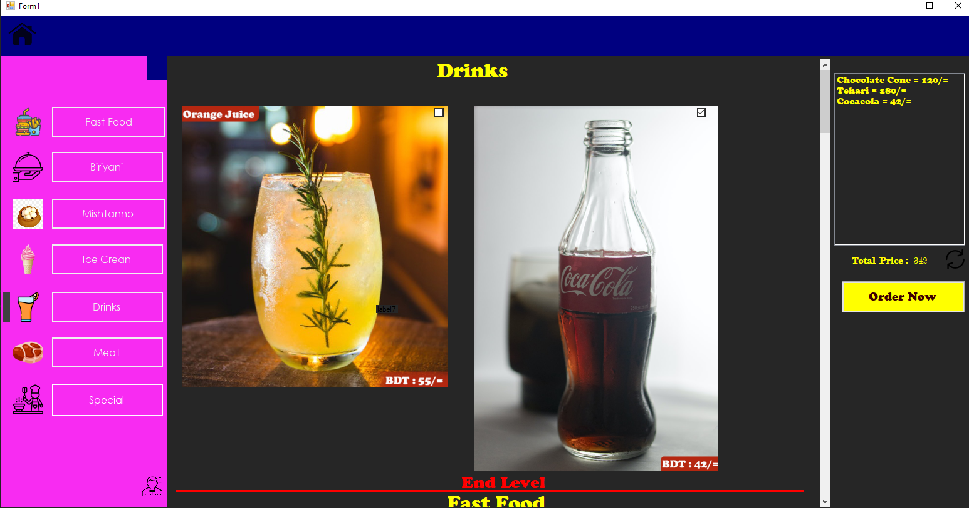

Figure 6.2: **Design** **Selected Food**

1. After clicking order now button, user see this payment page it has a payment box and food

list with a verification boxes. It’s for the food list message and verification money. This

Mainly help user for order the food.

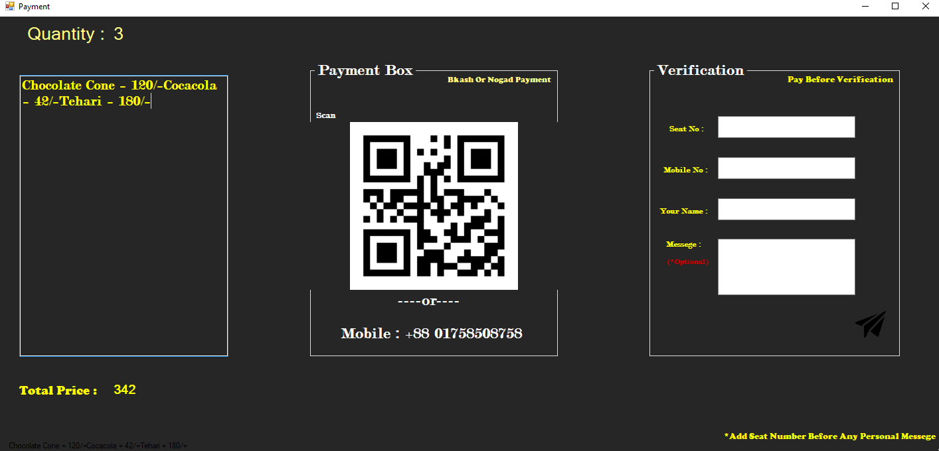

Figure 6.3: **Order Process**.

1. Here user write their name seat no and phone number for serve food exact way and and sent the food list to chef with verification money.

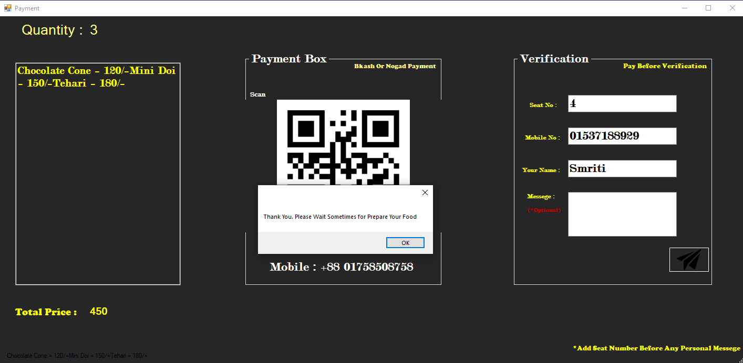

Figure 6.4: **Verification**

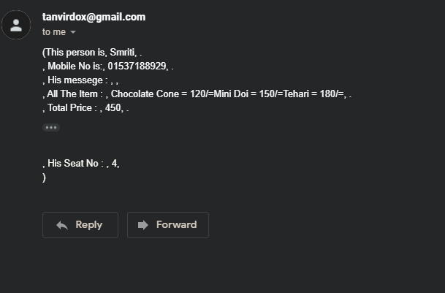

Figure 6.4.1: **Verification Mail**

1. After click front home icon, you see this text box and unlock button here just owner know this secure code and it’s the way of calculated box. It’s only accessing way to go to database.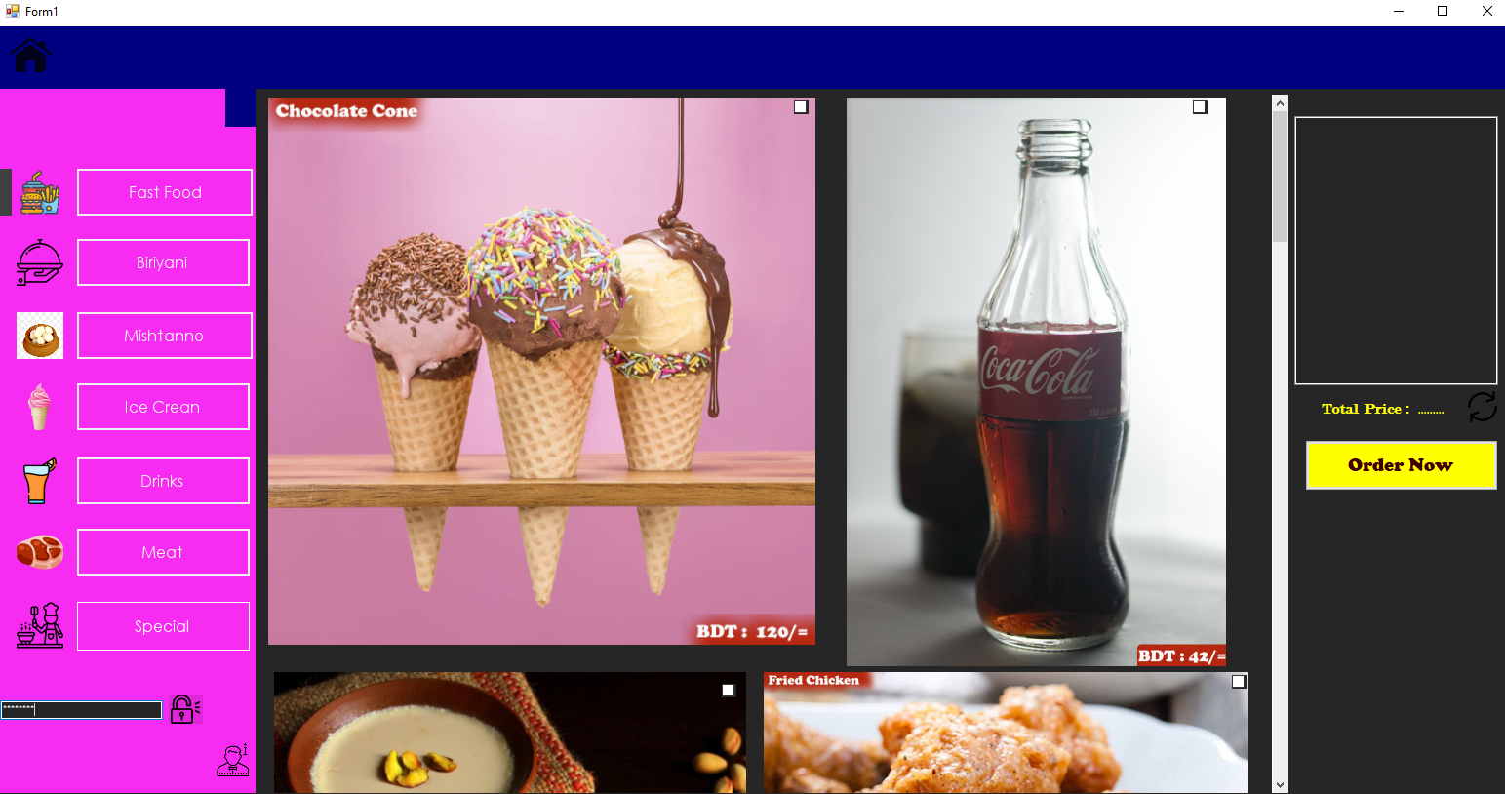

Figure 6.5: **Developer mood Password system**

1. Here two boxes are so user-friendly system for calculate all of the restaurant’s thing. It’s so useful owner just write number of your on add text box. It always calculates sum and showed to total text box. And if you click arrow button total text boxes data go to cost button then second click its going to sold text box.

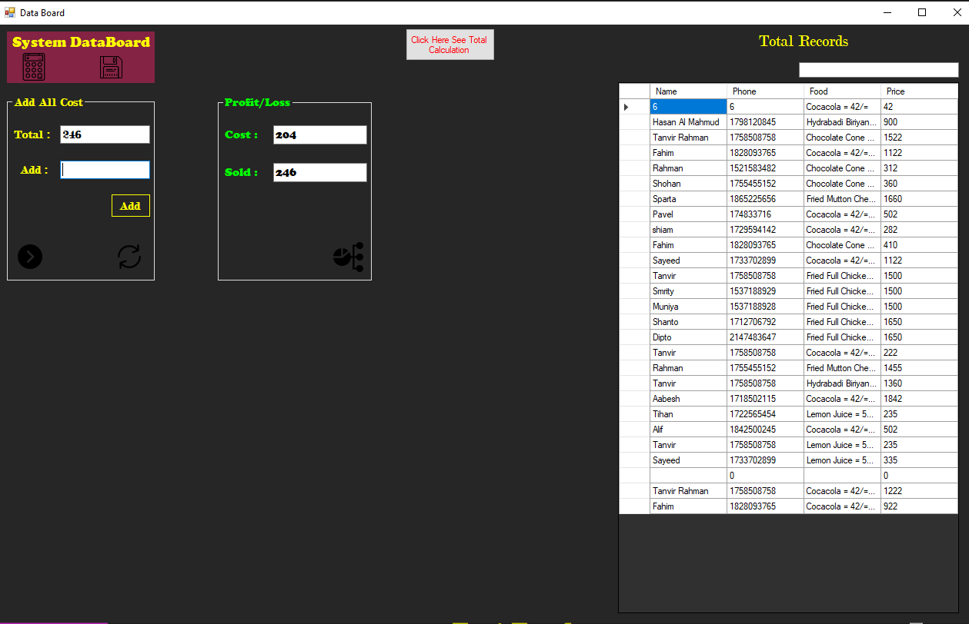

Figure 6.6: **Calculate Data**

1. This pic chart show owner ever days total profits or loss and percentage.

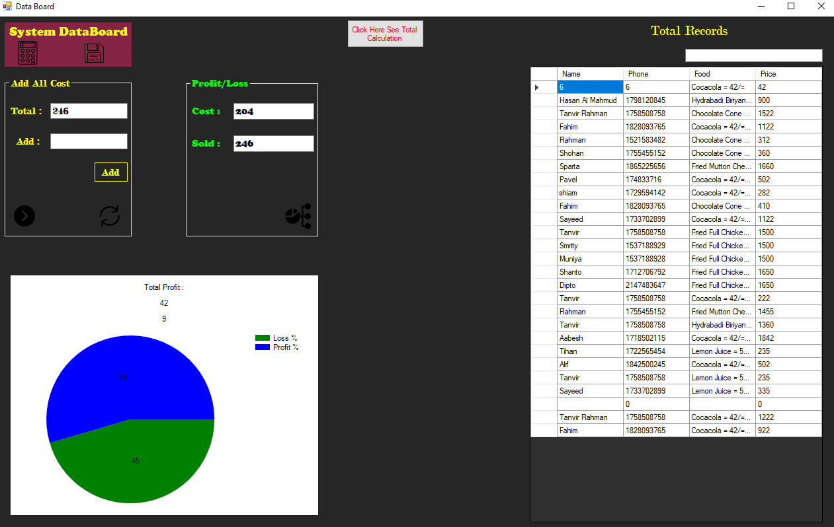

Figure 6.7: **Record & Chart**

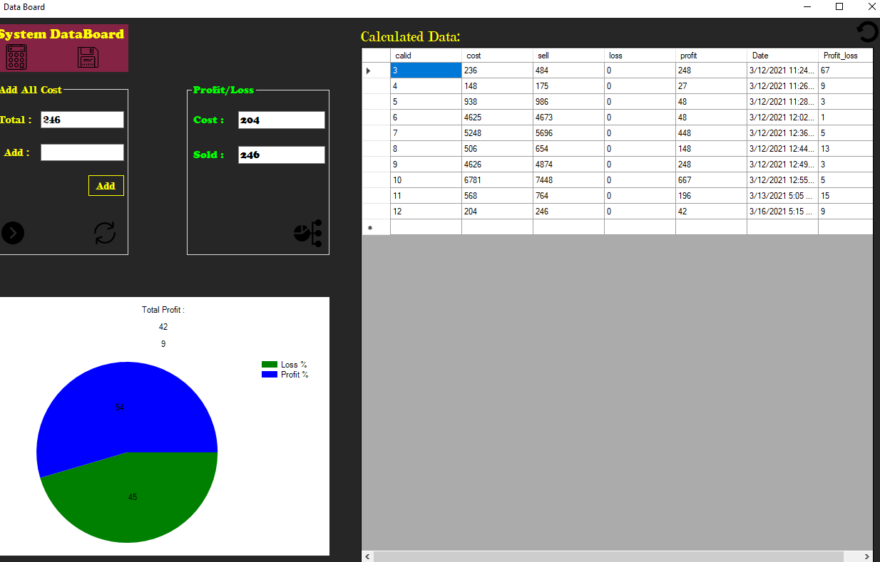

Figure 6.8: **Calculate Data record table**

Just click order now. Then you write message on (message box )-*Before any Personal message customer have to type his (seat no) to-seat box.

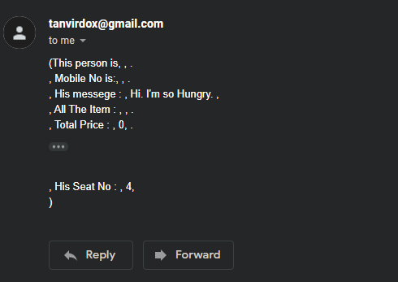

Figure 6.8: **Calculate Data record table**

**private void Pricelbl2_Click(object sender, EventArgs e)**

**Chapter 6**

**Perfection**

In this report we describe all about that how a user uses our wonderful software and how a to restaurants owner and his chef use this software. This fully fresh and good locking dark UI based software. By making process of this software, we all the team member are try so hard to make it user-friendly, useful and also, we think about setup calculation system of this software. It has mail system to send mail to chef for prepare customers food. It’s called order system. After select food and payment, you see a verification box. You type here some data and your payment phone number for verification and find your seat. You also able to send some message. In this way we think that every restaurant will be able to decrease waiter because they don’t need many people to listen customer’s order. Customers just come to restaurant and order food by this software so they don’t need to call waiter many times. If they need waiter, they just send message to kitchen. By this software an owner also able to maintain his calculation Unerringly. He able to see every-days data. For calculation there have a unique and useful calculator. We setup chart there for understanding calculation easily. So, we all the team members try to make a fulfill and useful software for this system.

**Future Plan**

* Make an android apps, this time customers be able to order by mobile phone. Update Software and graph chart for fulfill total calculation system.
* Secure password system.
* Update message system.
* Add WhatsApp message system.
* Add more food items.
* Update Database.

**Features**

* Multiple Food select system (Same type of food).
* It has refresh button so you handle and order food many times by onetime open this apps.
* Payment box for online payment system.
* Varication for payment and order food.
* Side panel always show you which button you clicked now.
* Food list is sort by button click.
* Customer name, phone number, listed food, price, datetime are be listed in a database table.
* It has to useful calculator.
* Chart show owner right calculation and profit/loss.
* It also has a calculation table.
* Search system customers database.
* Personal message system.

**Resources**

**https://github.com/Tanvir248/Two-Final-Project-Csharp/tree/main/Memo%20Apps**